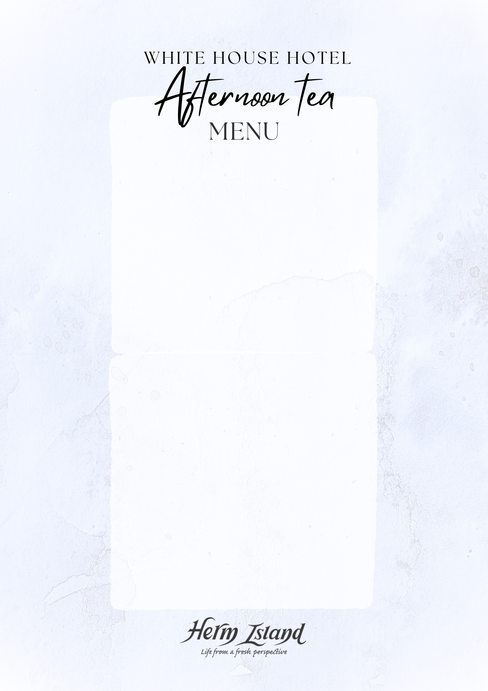

CREAM TEA £8.95pp
One homemade scone, clotted cream, strawberry jam,
Tea or coffee

AFTERNOON TEA £23.95pp
Three pieces of cake
One homemade sable biscuit
A selection of finger sandwiches
(smoked salmon and cream cheese, egg and cress,
cheese and chutney, coronation chicken)
Scone, clotted cream, strawberry jam
Tea or coffee

Add a cocktail to your afternoon tea £9

Add chocolate dipped strawberries
half punnet £11/ whole punnet £18

POOLSIDE LIGHT LUNCHES

FRESH CIABATTAS
served with dressed leaves and crisps

Roast chicken and bacon, garlic mayo, gem lettuce £16.95
Prawn Marie rose £16.95
Mature cheddar and homemade chutney £14.95
Salmon and cream cheese £16.95

HOMEMADE CIABATTA PANINIS
served with dressed leaves and crisps

Prosciutto, buffalo mozzarella & homemade pesto £16.95
Chicken melt £15.95
Tuna cheese £14.95

